**Marslino Edward**

**General Info:**

Last updated: [5/12/2024]

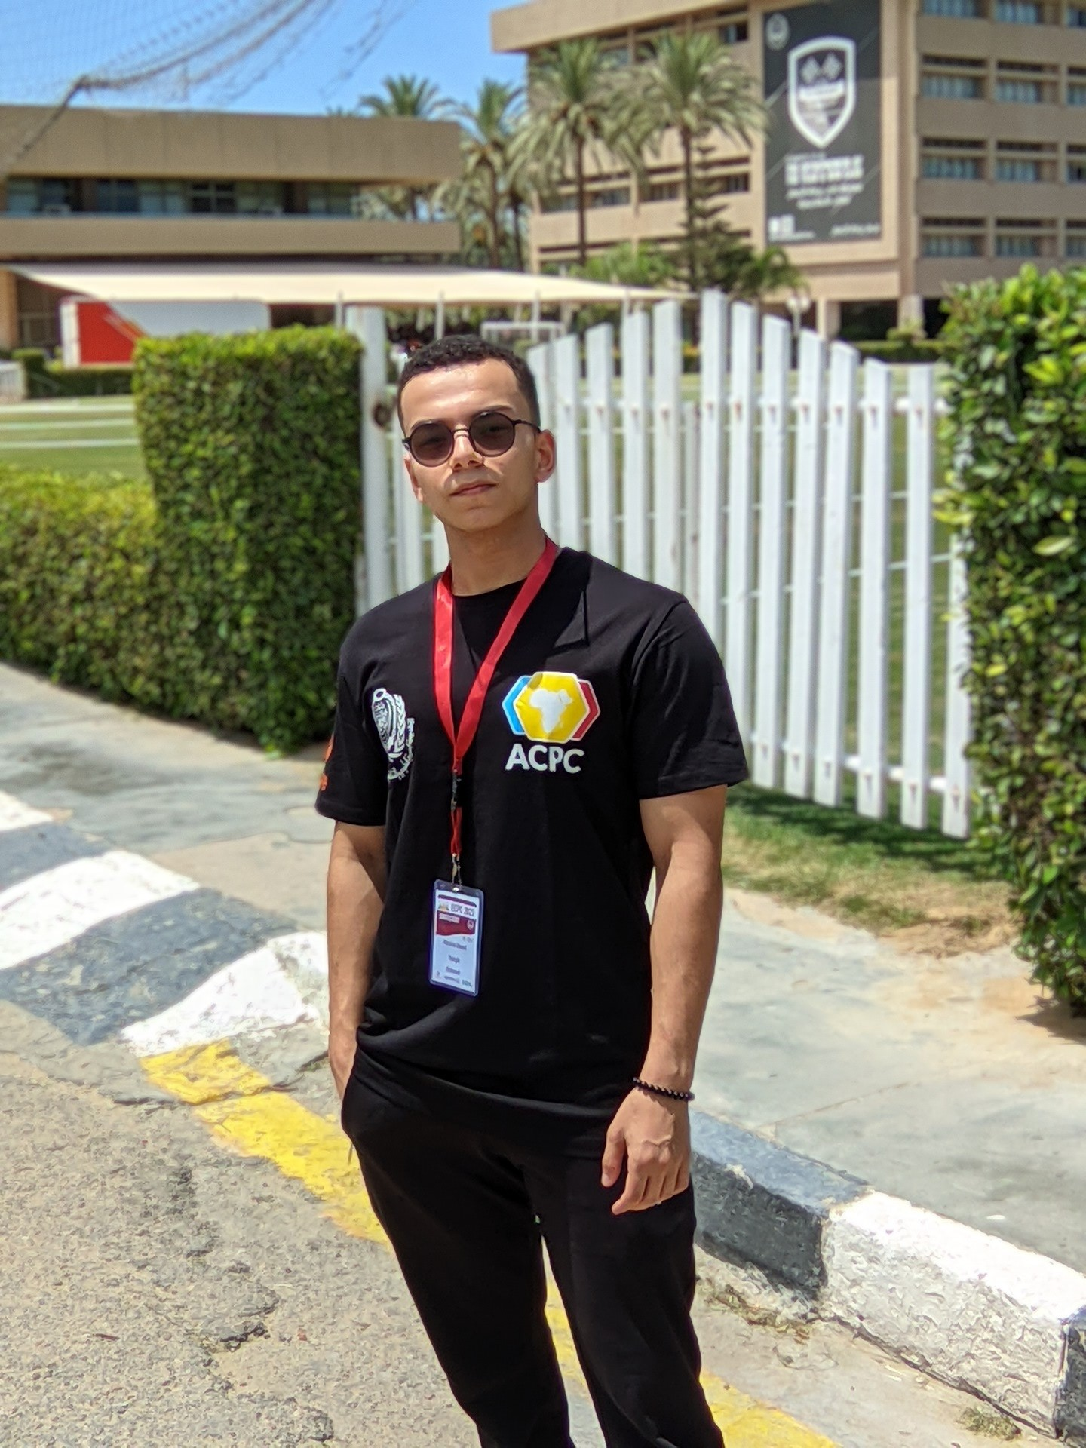

Full Name: Marslino Edward

Data of Birth: 5 of August 2004

Nationality: Egyptian

Marital Status: Single

Location: Matareya, Cairo, Egypt

**EXPERIENCE:**

Feb 2024 to Mar 2024

(Internship)

**Machine Learning Engineer**

At InfoTech

Jan 2024 to Feb 2024

(Internship)

**Machine Learning Engineer**

At CodSoft

Feb 2023 to Nov 2023

(Full-time)

**Data Entry Clerk**

At Covo Connect

ICPC

(Competition)

**ECPC** Competitor **2022**

**ECPC** Competitor **2023**

Dec 2022 to July 2023

(Scholarship)

**ALX-Africa**

Software Engineering

April 2023

(Student Activity)

**AI instructor Python**

At GDSC

Mar 2023

(Student Activity)

**Problem Solver Instructor**

At F12

**EDUCATION**:

2021: 2025

**Artificial Intelligence in Computer Science**

El Shorouk Academy (SHA), Egypt

Overall Grade: Excellent

**Thanaweya Amma**

Elnokrashy, Egypt

Overall Grade: Very Good

2021

**Language:**

* Arabic: Fluent.
* English: Advanced.

**Skills:**

* Programming Languages: Proficient in C++, C#, Python.
* Familiarity with AI, Machine learning concepts, Telegram bots and Advanced Python Libraries, currently advancing expertise through ongoing studies.
* Kaggle Notebook Master
* Problem Solving: Critical thinking skills to identify and solve complex programming challenges.
* Proven ability to adapt and learn, showcased by active participation in the ECPC for problem-solving.
* Strong communication and collaboration skills, essential for effective teamwork in dynamic environments proved at ALX-Africa and a lot of students activity.
* Unity multi projects beginner game development.
* Business Intelligence Tools: Tableau, Power BI.
* Database Management: Knowledge of SQL.
* Web Development: Experience in HTML, CSS.
* Demonstrated aptitude in efficiently navigating and utilizing Microsoft applications.
* Hands-on experience as a Data Entry Clerk at Covo Connect, emphasizing attention to detail and organizational skills.
* Professional in dealing with Microsoft applications with 60 Wpm 98% accuracy.

**Contact Info:**

Mobile: +201228767453  
Email: lino.edward11@gmail.com

Linkedin: <https://www.linkedin.com/in/marslino-edward/>

Github: <https://github.com/marslinoED>  
CodeForces: <https://codeforces.com/profile/MarslinoEdward>  
Kaggle: <https://www.kaggle.com/marslinoedward>   
Facebook: <https://www.facebook.com/lino.edwar/>

Twitter: <https://twitter.com/MarslinoEd>